**Module-3: Docker – I Assignment – 3**

**To Do :**

● Use the saved image in the previous assignment

● Upload this image on Dockerhub

● On a separate machine pull this dockerhub image, and launch it on port 80

● Start the apache2 service

● Verify if you are able to see the apache2 service

**Solution :**

*//The container is not running, it exited since I stopped the Docker Machine. So,starting the containers again

sudo docker run -itd -p 81:80 sindevops/img_01

**Pushing the image to dockerhub :**

//Logging in t dockerhub,

Sudo docker login //Logged to DockerHub.

Sudo docker images

Sudo docker images

sudo docker push sindevops/img_01 // Image uploaded/pushed.

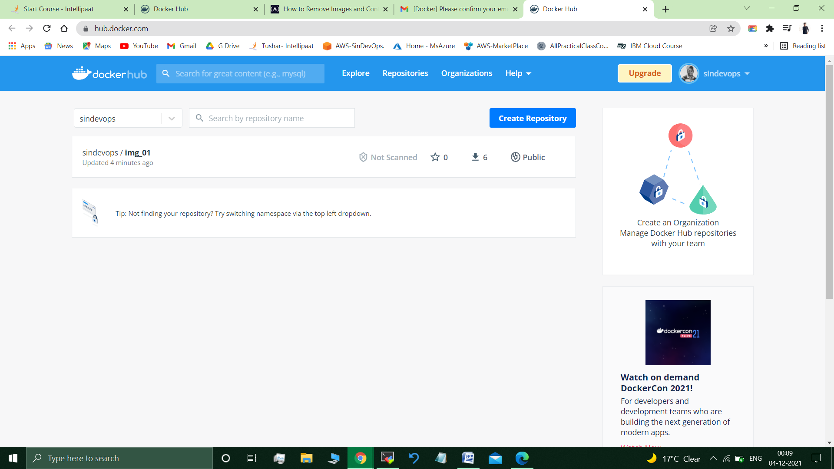

**On another Docker Machine :**

**On another docker machine :-**

Sudo docker login

sudo docker pull sindevops/img_01

sudo docker images

//REPOSITORY TAG IMAGE ID CREATED SIZE

sindevops/img_01 latest c1ff285bc668 44 hours ago 218MB //

sudo docker run -itd -p 83:80 sindevops/img_01

//Mounted on Port 83,as 80 was already occupied.

//ba7265815d6c8181c23c55c70764642b8e755ad390a7a483e17a4f0ff271038c

sudo docker ps

// CONTAINER ID IMAGE COMMAND CREATED STATUS PORTS NAMES

ba7265815d6c sindevops/img_01 "bash" About a minute ago Up About a minute 0.0.0.0:83->80/tcp, :::83->80/tcp awesome_solomon

sudo docker exec -it ba7265815d6c bash

/# service apache2 status

* apache2 is not running

# service apache2 start //started apache2.

//Allowed all traffic inbound port of the machine.

Google search :Public IP of vm :83

// <http://3.14.134.236:83/> 🡪 apache2 web server available/displayed.

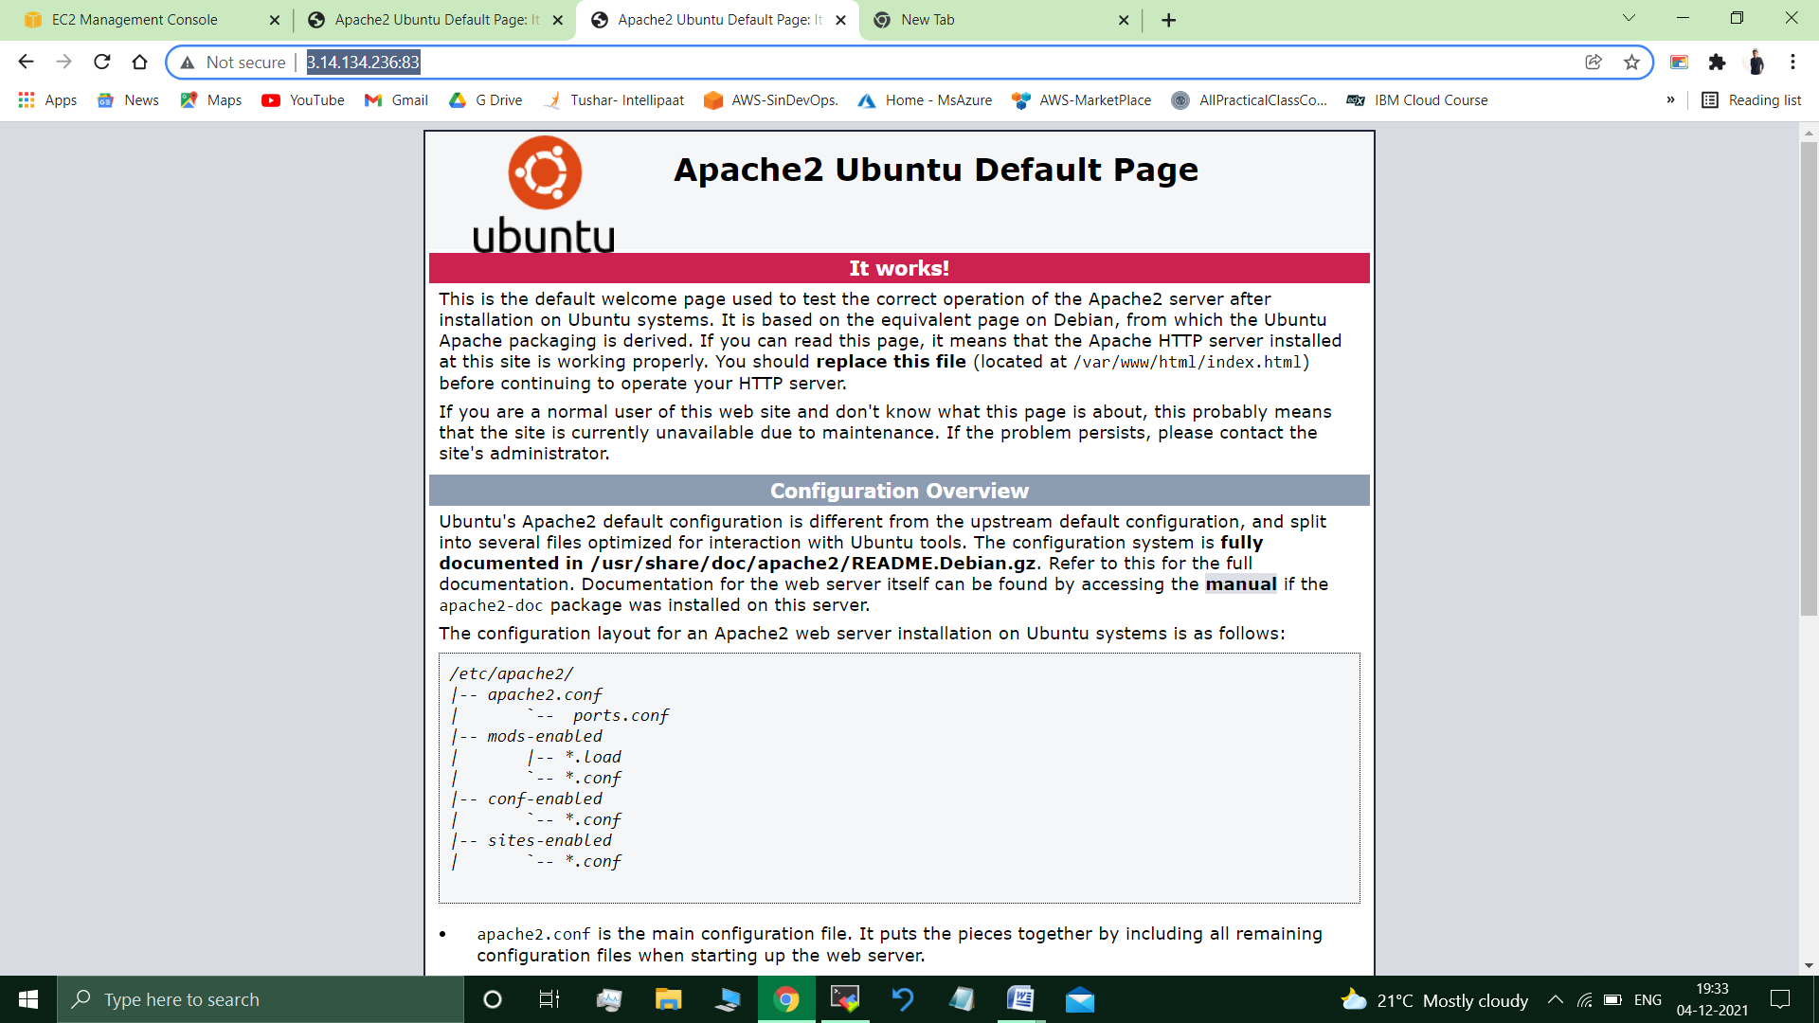

**Submitted By : Tushar Sinha**

**Email ID :** [**sinhatushar17@gmail.com**](mailto:sinhatushar17@gmail.com)

**Enrolled in the “DevOps Architect Master’s Training Program”**